Lecture 3:

Next lecture is 2/19/2019 (Tuesday)

(online) quiz #1

Back to Stock Market:

**Assignment 1:**  label each week as follows:

+1 means that it was a good week to be invested in your stock

1. means it is better to be in cash

Design some consistent rules to classify weeks

(start with 2018)

(do not submit, but do it)

**Assignment 2:**

50-day moving -

Consecutive W down days

W – 50 DAYS

W = 1,2,3,4,5

Hyperparameters

Implement 2 strategies:

Bollinger Band trading

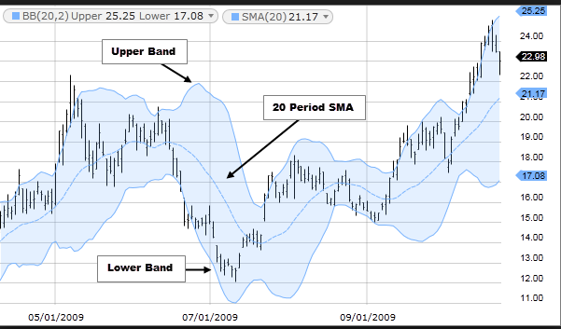

Suppose W = 20 days

For each day, compute 20-day MA and 20-day standard deviation

Consider the “channel” (MA – 2*std, MA + 2*std)

Buy if (Adjusted Closing) Price < MA - 2*std

(buy if the price became too low)

Sell if:

1. you own stock
2. price is > MA -2 * std

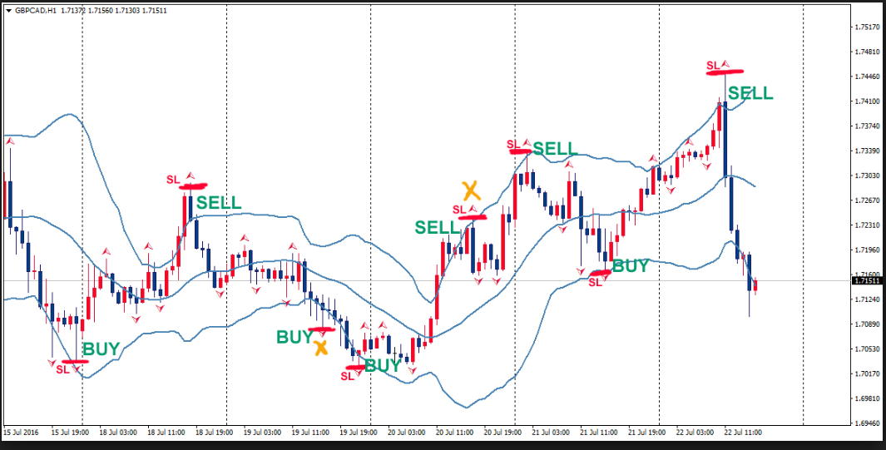

MA(W days) +/- k * st_dev(W days)

You will investigate: whicj combination of W and k gives you the best result

---- each time you trade, MET college gives $100

----- you compute average gain/loss per trade

Trade_bollinger(year, W, k) -----🡪 average gain/loss pr trade

Ideally, we want to plot the results

Take W = 10, 20, 30, …., 100 days

k = [0.5, 1, 1.5, 2, 2.5, 3, 3.5]

Plot (and color) points in (W, k) coordinates

Green ---🡪 average profit

Red -----🡪 loss

Use size of your point to indicate the magnitude

**Assignment 3**

Take two windows W_short and W_long. Compute moving averages for both

If MA(short window) > MA(long window) ----🡪 buy

If MA(short window) < MA(long window) and

(you own stock) ----------🡪 sell

Example: compute trimmed mean

X = [ 2, 3, -10, 10, 7]

Mean = 12/5 = 2.4

Trimmed : remove max, remove min, then compute average over the remaining elements

X ---------🡪 remove 10 (max), then remove -10 (min)

Y =[2, 3, 7]

Trimmed mean is 4

Q: given 6x6 matrix, compute sum of elements for rows 1,2 and 5

Q: extract every third row and every second column

Q: put everything in reverse

A matrix is symmetric if

Aij = Aji

Q: How to check if matrix is symmetric?

Summarize: